**Testing Document**

1.Intended Audience and Purpose

This document provides the testing plan and results, corresponding to the requirement from the user.

2. How to use the document

You may refer to the content section for the structure of the document, in which Sec. Testing Cases collect the unit and module test information from each part; Testing Plan shows the steps and expected results of the integration test; Results describes the real world data out of the test.

1. **Testing plan**

Test plan: the test method mainly relies on inputting information to the interface, observing the interface response time, response results and other evaluation whether it meets the test expectation. The test is mainly functional test, including registration, login, logout, import song list, obtain recommended song list, display songs and other functions. Observe whether the test results meet the expected output and meet the user demand analysis, so as to evaluate the advantages and disadvantages of the recommendation system.

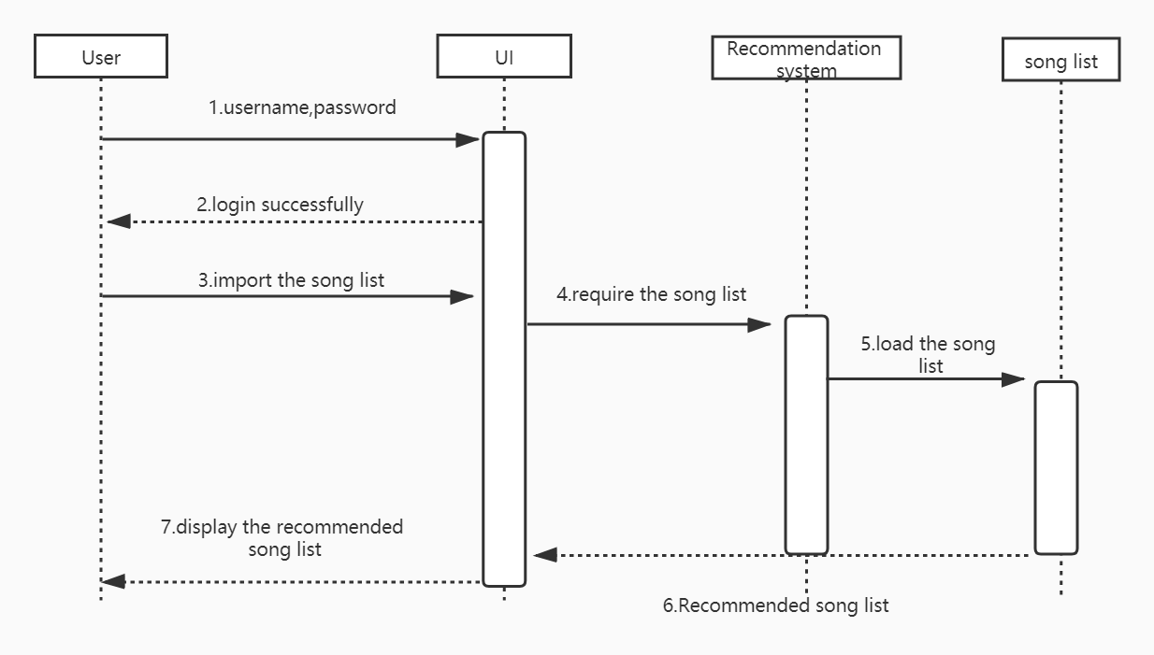

Function test

|  |  |  |  |
| --- | --- | --- | --- |
| Function | Description | Input | Expected Output |
| 1.register | User registers the system | Register button | Register page |
| 2.input the register information | User inputs the register information | E-mail,Userid,password,confirmpassword | Register success |
| 3.login | User logins the system | Login button | Login page |
| 4.input the login information(true) | User inputs the correct information | Userid ,password | Login success |
| 5.input the login information(false) | User inputs the false information | Userid,password | Return the login page and display the error message |
| 6.logout | User logouts the system | Logout button | Confirm message(yes or not) |
| 7.import the song list | User imports the song list for recommend | Song list | Import success |
| 8.get the recommended song list | User gets the recommended song list | Recommend button | Recommended song list |

1. **Testing case**

**UI**

|  |  |  |  |
| --- | --- | --- | --- |
|  | Description | Input | Expected output |
| 1. register(request) | Register in the system | Username, password , email , (repeat) password | {'success': True,  'error': ''} |
| 2. index(request) | To get into the index html | Username, password | {'success': True,  'error': ''} |
| 3. recommend(request) | To recommend a music list | A list of music | A list of music |

**Algorithm**

|  |  |  |  |
| --- | --- | --- | --- |
|  | Description | Input | Expected output |
| 1.lst_dist(lst1, lst2) | calculate distance between 2 music lists | lst_dist(lst2music['伤感翻唱版集合'], lst2music['又是一个睡不着的夜晚']) | 5.0 |
| 2.music_dist(music1, music2) | calculate the distance between 2 musics | music_dist('星河清梦', '繚 星') | 5.0 |
| 3.most_similar_lst(lst) | get the most similar music list | most_similar_lst(lst2music['刷题 看书 学习 工作 冥想']) | ({'夏 日 喝 汽 水 lofi', '我 去 宇 宙 偷 星 星，放 在 夜 里 等 你??', '浮生若梦', '银河赴约 - (网易云音乐助力高考自制曲目)', '你 能 來 保 護 我 的 世 界 嘛', '等', '风的小径', '夜里失联', '这个深海是你的眼眸', '奇怪吗'}, 5.0) |
| 4.most_similar_music(music) | get the most similar music | most_similar_music('无人之岛（翻自 任然）') | ('好想好想（翻自 群星）', 5.0) |
| 5.recommend(lst) | recommend according to music list | recommend({'呼吸', '无人之岛（翻自 任然）', '水星记', '像鱼', '大鱼 - (动画电影《大鱼海棠》印象曲)', '千千阙歌(Live)', '心はいつもあなたのそばに Piano'}) | {'永不失联的爱', '多远都要在一起', '你的样子', '想い', '是想你的声音啊 - (你快听 滴答滴)', '古诗中国', '心领神会', '你还好吗', '不爱我', '玻璃之情', '或是一首歌', '那个她', '秋海棠', '看见你的声音 - (电视剧《想见你》插曲)', '好想好想（翻自 群星）'} |